Technical Assignment for QA

*Take-home challenge*

We are happy that you are interested in joining the QA team at UPS!

The goal of this is for you to showcase your QA skills. This take-home challenge is designed for you to showcase your technical skills in more detail. It should take max. 90 minutes of your time. At UPS, we are big advocates for work-life balance: you are welcome to return the completed assignment within 7 days.

From these exercises, we would like to get an impression of what you consider good QA is, and how you put it to practice. It has 2 parts:

1. First centering around test case design for a common piece of functionality

and around requirement analysis for a problem from our business domain.

2)Second one focusing on creating a simple automated test.

We’ll use your answers as a conversation point during the interview, to understand the reasoning behind them.

Please share your answers to Questions 1 by email (e.g. adding your commentary to this document). For Question 2 either send us your solution in a zip file by email, or upload it to a git repository we can clone. If there are any special instructions how to run the automated test, please mention it.

Best of luck - we hope you have fun completing the challenge!

# Question 1 – Designing test cases & Business requirements analysis

**Case Study**

The main list view is this:

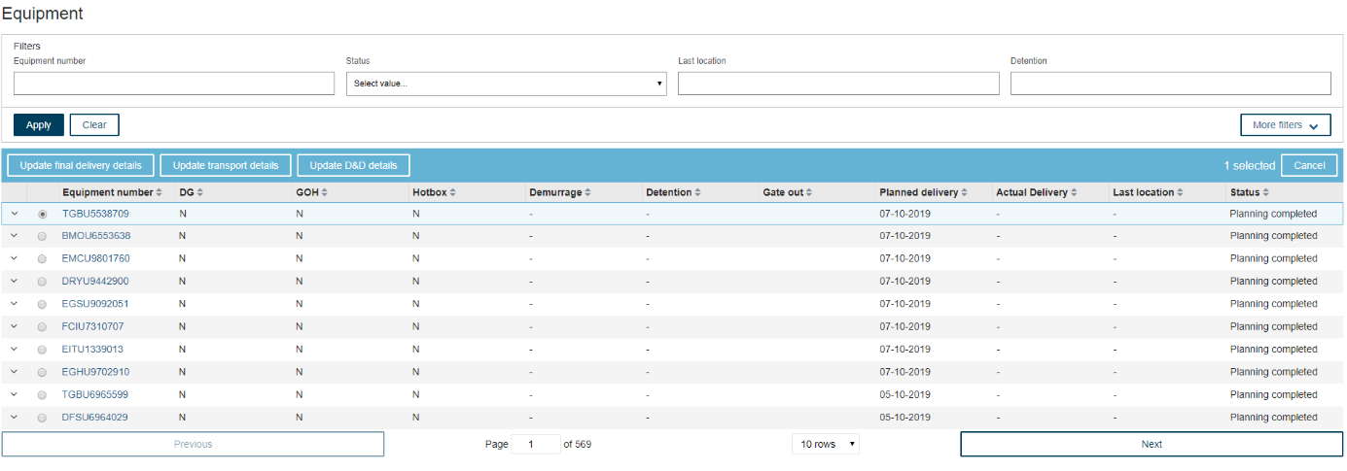

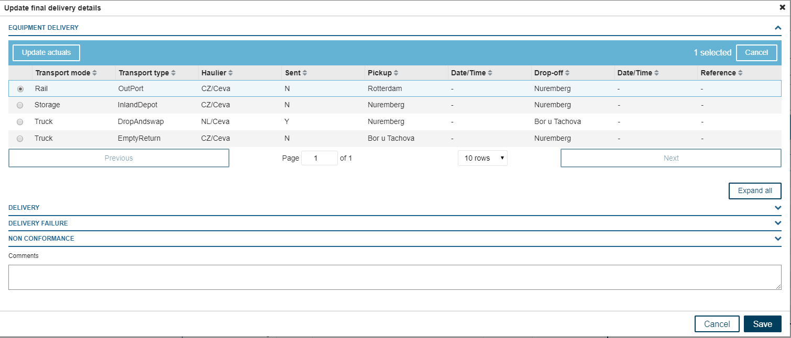

Clicking “Update actuals” (once a record is selected) will show the below screen:

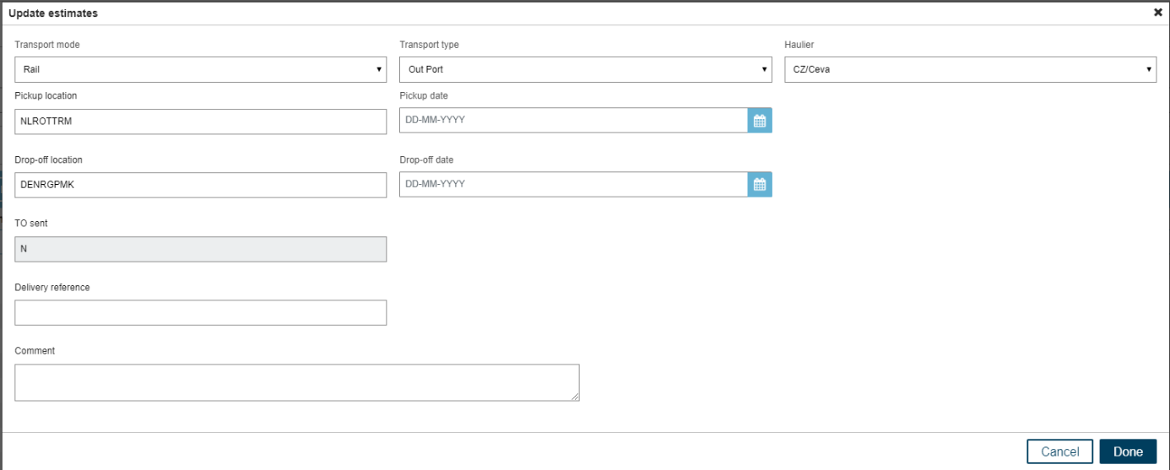

All of these should be available in a bulk upload function

Drop-down values:

1. Transport Mode: Truck, Barge, Rail, Storage
2. Transport Type: transport type are unique per transport mode.

|  |  |
| --- | --- |
| **Transport Mode** | **Transport Type** |
| Truck | Gas check, Fumigation, Inland Depot, Shunt, Out Port, Drop and swap, LiveTip, MilkRun, Empty return, DeRig, Dark Storage |
| Barge | Out Port, Inland Depot |
| Rail | Out Port, Inland Depot |
| Storage | Inland Depot, Dark Storage, Decon Warehouse, DeRig |

1. Haulier: CEVA, Damco, Maritime Transport

Users want to have a bulk upload functionality via an Excel file where they can update or insert multiple records via one Excel file.

We would like to see:

1. How would you write this as BDD (Gherkin) test scenarios/cases?

**Feature:** Update equipment details

**Background:**

Given that the user has access to different features and functionalities of the application

And  
the user has logged into the application and performed all the steps that is required to proceed ahead with the scenarios mentioned below:

**Scenario 1:**

Given that the user successfully navigates to the ‘Equipment’ page

When a user selects a record from a set of records

And

A user clicks on “Update final delivery details”

Then the user should be navigated to the “Update final delivery details” page without any issues

**Scenario 2:**

Given that the user successfully navigates to the ‘Equipment’ page

When a user clicks on ‘More Filters’ button

Then the user should be presented with additional filter options.

**Scenario 3:**

Given that the user successfully navigates to the ‘Equipment’ page

When a user selects the filter criteria

And

A user clicks on “Apply”

Then the records should be displayed only based on the filter criteria

**Scenario 4:**

Given that the user successfully applies required filter criteria on the ‘Equipment’ page

When a user clicks on the ‘Next’ Button at the bottom of the screen

Then the next set of records should be displayed only based on the filter criteria, the number of rows selected by the user.

**Scenario 5:**

Given that the user successfully applies required filter criteria on the ‘Equipment’ page

When a user clicks on the ‘Next’ Button at the bottom of the screen

Then the page number should be increased by ‘1’ each time the user clicks on the ‘Next’ button.

**Scenario 6:**

Given that the user successfully applies required filter criteria on the ‘Equipment’ page

When a user clicks on the ‘Previous’ Button at the bottom of the screen

Then the page number should be decreased by ‘1’ each time the user clicks on the ‘Previous’ button.

**Scenario 7:**

Given that the user successfully applies required filter criteria on the ‘Equipment’ page

When there are no records available for the filter criteria

Then the table should display no records available.

**Scenario 8:**

Given that the user successfully applies required filter criteria on the ‘Equipment’ page

When there are no records available for the filter criteria after a certain limit

Then the ‘Next’ button should be disabled.

**Scenario 9:**

Given that the user successfully applies required filter criteria on the ‘Equipment’ page

When there are no previous records to be shown

Then the ‘Previous’ button should be disabled.

**Scenario 10:**

Given that the user selects a record on the ‘Equipment’ page based on certain filter criteria

When user clicks on ‘Cancel’ button on the top right corner of the table

Then the selected record should be unselected.

**Scenario 11:**

Given that the user successfully navigates to the ‘Equipment’ page

When a user selects some filter criteria

And

A user clicks on “Apply”

Then the records should not be displayed if any of the mandatory field(s) are left blank

**Scenario 12:**

Given that the user successfully navigates to the ‘Equipment’ page

When a user selects the filter criteria

And

A user clicks on “Cancel”

Then the criteria entered by the user should be removed/reset to blank.

**Scenario 13:**

Given that the user successfully applies required filter criteria on the ‘Equipment’ page

When user selects a record from the applied filter criteria

And

A user clicks on ‘Update Transport details’ button

Then the user should be navigated to the Update Transport details page without any issues.

**Scenario 14:**

Given that the user successfully applies required filter criteria on the ‘Equipment’ page

When user selects a record from the applied filter criteria

And

A user clicks on ‘Update D&D details’ button

Then the user should be navigated to the Update D&D details page without any issues.

**Scenario 15:**

Given that the user successfully applies required filter criteria on the ‘Equipment’ page

When a user does not select any record from the applied filter criteria

Then the user should either be prompted to select a record to update or the ‘update’ options should be disabled.

**Scenario 16:**

Given that the user successfully applies required filter criteria on the ‘Equipment’ page

When user selects a record from the applied filter criteria

And

A user clicks on ‘Update final delivery details’ button

Then the user should be navigated to the Update final delivery details page without any issues.

**Scenario 17:**

Given that the user successfully navigates to the “Update final delivery details” page

When a user selects a record from the set of records

And

The user clicks on ‘Cancel’ button on the top right corner of the table

Then the selected record should be unselected.

**Scenario 18:**

Given that the user successfully applies required filter criteria on the ‘Equipment’ page

When user selects a record from the applied filter criteria

And

A user clicks on ‘Update final delivery details’ button

Then the user should be navigated to the Update final delivery details page without any issues.

**Scenario 19:**

Given that the user successfully navigates to the “Update final delivery details” page

When a user clicks on the ‘Expand All’ option

Then all the sections under the ‘Expand All’ option should be expanded to view.

**Scenario 20:**

Given that the user successfully navigates to the “Update final delivery details” page

When a user selects a record from the set of records

And

A user clicks on “Update actuals”

Then the user should be navigated to the “Update estimates” page without any issues

**Scenario 21:**

Given that the user successfully navigates to the “Update estimates” page.

When the user selects ‘Truck’ as the Transport mode option

Then the relevant transport type option “**Gas check, Fumigation, Inland Depot, Shunt, Out Port, Drop and swap, LiveTip, MilkRun, Empty return, DeRig, Dark Storage”** only should be displayed in the drop down.

**Scenario 22:**

Given that the user successfully navigates to the “Update estimates” page.

When the user selects ‘Barge’ as the Transport mode option

Then the relevant transport type option “**Out Port, Inland Depot**” only should be displayed in the drop down.

**Scenario 23:**

Given that the user successfully navigates to the “Update estimates” page.

When the user selects ‘Rail’ as the Transport mode option

Then the relevant transport **type** option “**Out Port, Inland Depot**” only should be displayed in the drop down.

**Scenario 24:**

Given that the user successfully navigates to the “Update estimates” page.

When the user selects ‘Rail’ as the Transport mode option

Then the relevant transport type option “**Inland Depot, Dark Storage, Decon Warehouse, DeRig**” only should be displayed in the drop down.

**Scenario 25:**

Given that the user selects/fills all the required fields in the “Update estimates” page

When the user clicks on ‘Done’

Then the updates made should be saved.

**Scenario 26:**

Given that the user selects/fills all the required fields in the “Update estimates” page

When the user clicks on ‘Cancel’

Then the updates made should not be saved.

**Scenario 27:**

Given that the user has access to bulk upload functionality

When the user uploads the file with the proper data

Then the records should be updated based on the data in the file.

**Scenario 28:**

Given that the user has access to bulk upload functionality

When the user uploads the file with the proper data

And

The records are updated as expected

Then the user should be able to perform all the operations that could be performed otherwise.

1. What questions/clarifications do you need to further ask business or developers, if any?

Q1: Are there any mandatory fields that the user has to fill in any of the pages

Q2: When a user clicks on the ‘Expand All’ option, should the details under that section be read-only or can it be editable by the users. If editable, then should everything be editable or any specified fields.

Q3: If a user performs any actions, such as update or filter criteria, then should there be any message to be displayed to the user?

Q4: Does the comment text box accept be alpha-numeric and should it accept special characters?

Q5: Is there a maximum limit on how many rows to be displayed in one page?

Q6: What is the significance of Haulier field, and does it have any dependency with other options chosen by the user?

Q7: Should delivery reference be auto populated or if it is to be filled manually, does it have any special rules?

1. Draft Excel template that you would propose to the developers to use

Present in the provided GitHub URL with the name “[Equipment Bulk Upload.xlsx](https://github.com/aditho97/test/blob/main/Equipment%20Bulk%20Upload.xlsx)”

1. Provide any comments/suggestions to improve the scenario presented above.

1: If there are any mandatory fields to be filled in by the user, that should be marked properly probably with a * sign next the name of the field.

2: If there is an ‘Expand All’ option for some sections, then once the sections are expanded, there should be an option to collapse the expansion. This could be done by a ‘Collapse All’ button, which should only be enabled if the sections are expanded.

3: There is a text box for comments and delivery reference, it should not accept unwanted special/wildcard characters.

You can use MS Word, Notepad, Excel or similar application.

# Question 2 – Automate a Scenario

If you have worked on a test automation for a windows/desktop based application using any tools like WinAppDriver or AutoIT please try to automate the below scenario.

Steps to Follow:

1. Open the windows application.
2. Validate the landing page opens.
3. Search for an object.
4. Click on one of the objects on the search page and make sure it navigates to the corresponding page.
5. If there is a report, write a code to validate the reports are opening with valid data.

Or

Write an automated test for this webpage: <https://www.ups.com/us/en/Home.page> . You can use the technologies you’d like, although we’d prefer if it’s a close to our tech stack (.NET).

Expected outcome: to either send a project by zip or push it to a git repository we can clone.

**Steps to follow:**

1. Open webpage https: //www.ups.com/us/en/Home.page
2. Validate Logo exists.
3. Navigate to the footer and count the total number of links.
4. Validate all the footer links are working.
5. Click on each link and make sure a different window opens.